Overview
The Request a replacement card page allows you to request replacement Veterans’ health card(s) (gold, white and orange) and, where applicable, Commonwealth Seniors Health and Pension concession cards.
A replacement card may be issued where your existing card has been lost, stolen, damaged or worn out.

The Request a replacement card screen.
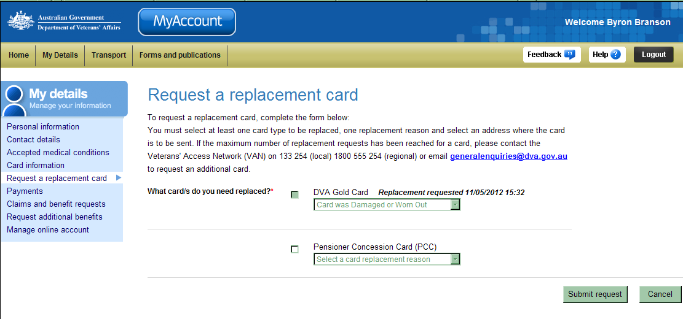
My details menu.
Cards selection.

 | Only cards which you currently hold will be displayed as available to request a replacement card.
Your new card(s) will be sent to your postal address, as displayed in MyAccount, within 10 business days. For urgent requests, please call the Veterans’ Access Network (VAN) on 1800 555 254.

Request a replacement card
To request a replacement card:
- In the Cards selection section, select the check box next to the card type you wish to request a replacement for.
- For the card selected, click on the Select a card replacement reason drop down box and select the reason you are requesting a replacement card.
- Repeat Step 1 to 2 for each card you wish to request a replacement for.
- Click on the Submit request button.

The Request a replacement cards screen updates.
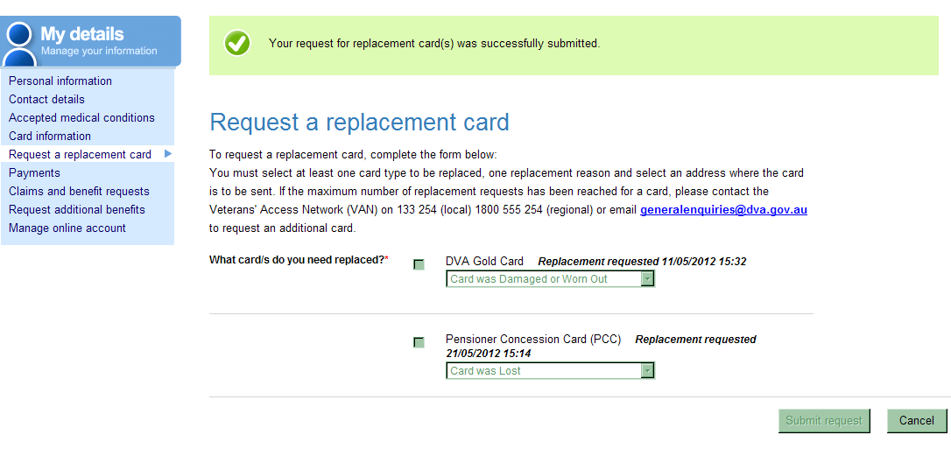
At the top of the screen, a green success message indicates your request was successfully submitted.
Next to each card you requested, a message indicates the date the request was made.

Other functions
 | To view another section and information from My details, click on a link in the My details menu to the left of the page.
 | To get additional help with the Request a replacement card screen, click on the Help button at to the top right of the page.
 | When you are finished using MyAccount, to log out and finish using the service in a secure way, click on the Logout button.

